**VCS Task**

**Task Description:**

Establish a new directory, populate it with script files, initiate an empty repository on GitHub, convert the local directory into a Git repository, and link it to GitHub for pushing the code into the repository. Perform merge, rebase, stash commands in following github repo.

**Step 1: Create a Local Directory and Populate with Scripts**

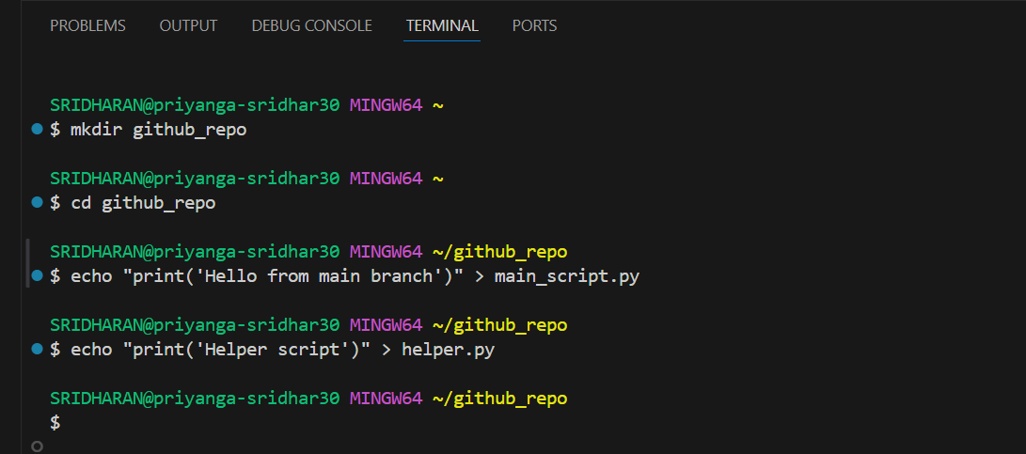

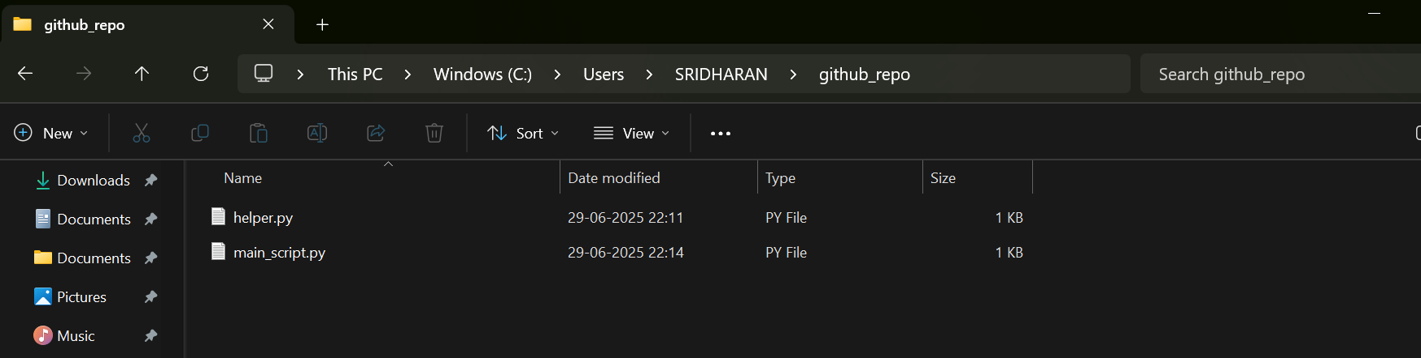

**Step 2: Initialize Git and Make Initial Commit**

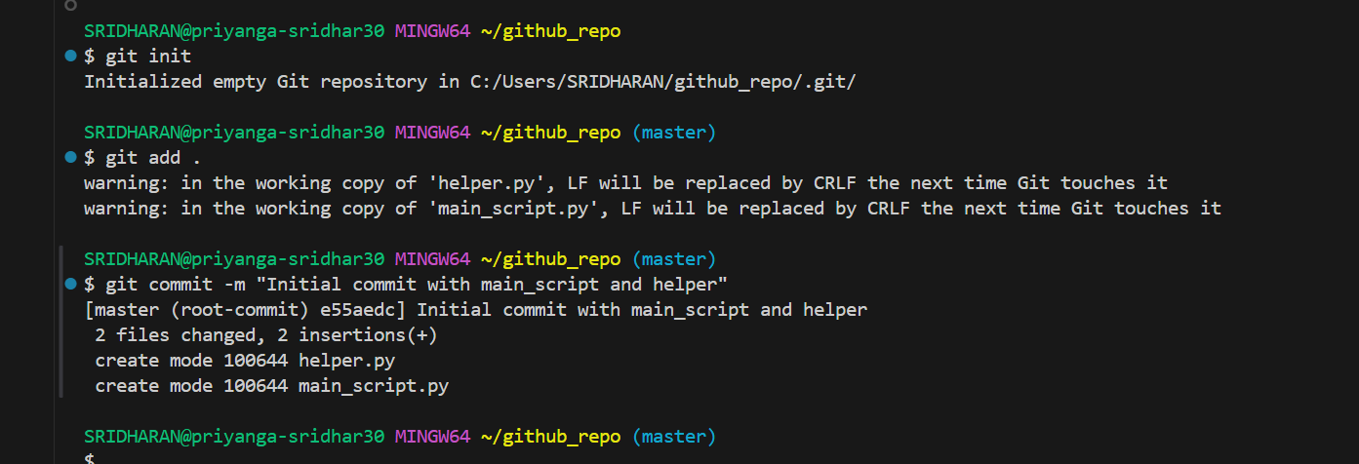

**Step 3: Create an Empty GitHub Repository**

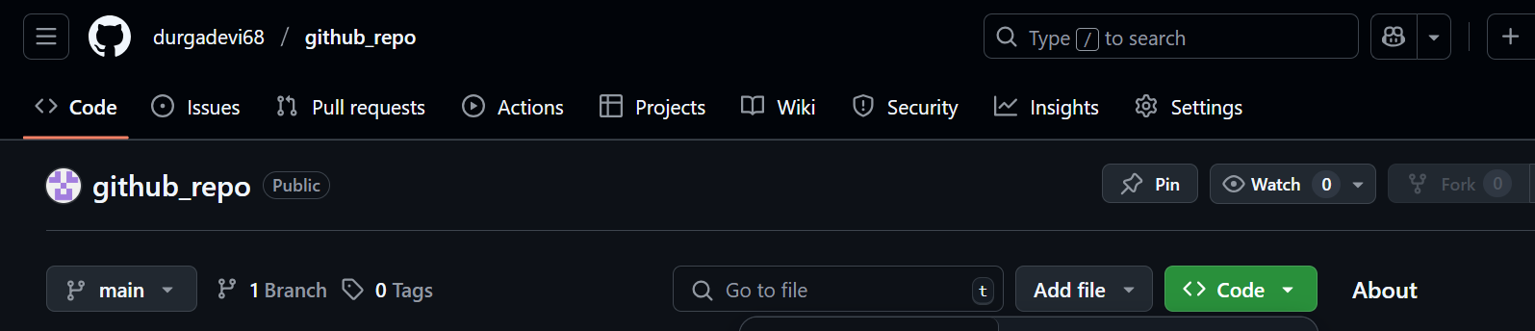

**Step 4: Link Local Repo to GitHub and Push**

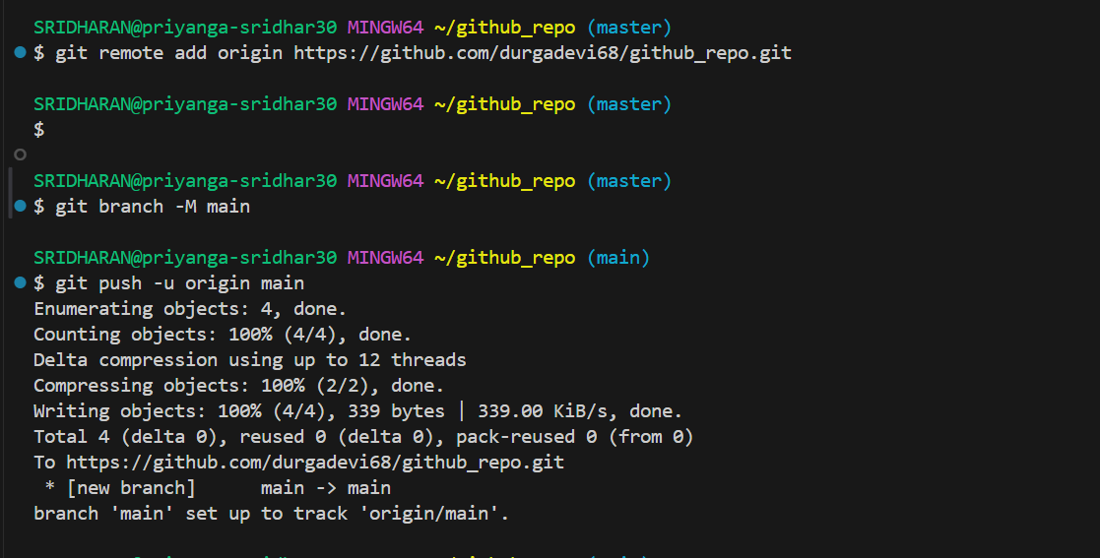

**Step 5: Create and Merge a Feature Branch**

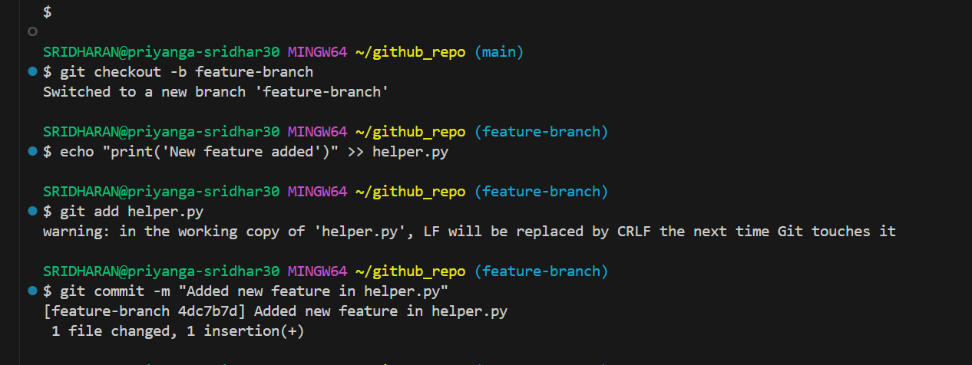

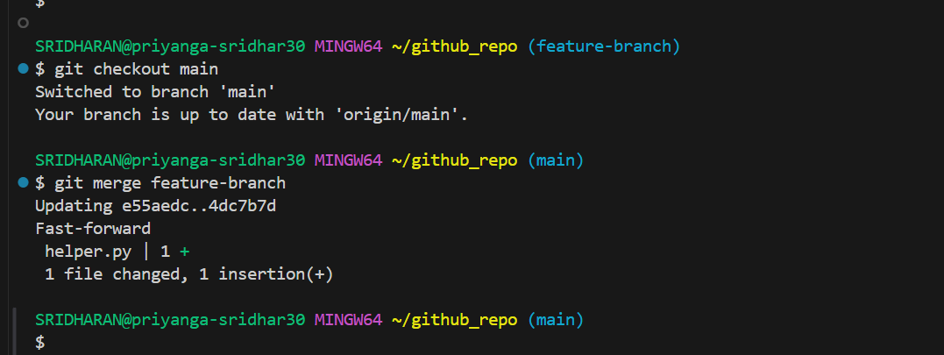

**Step 6: Rebase a Branch**

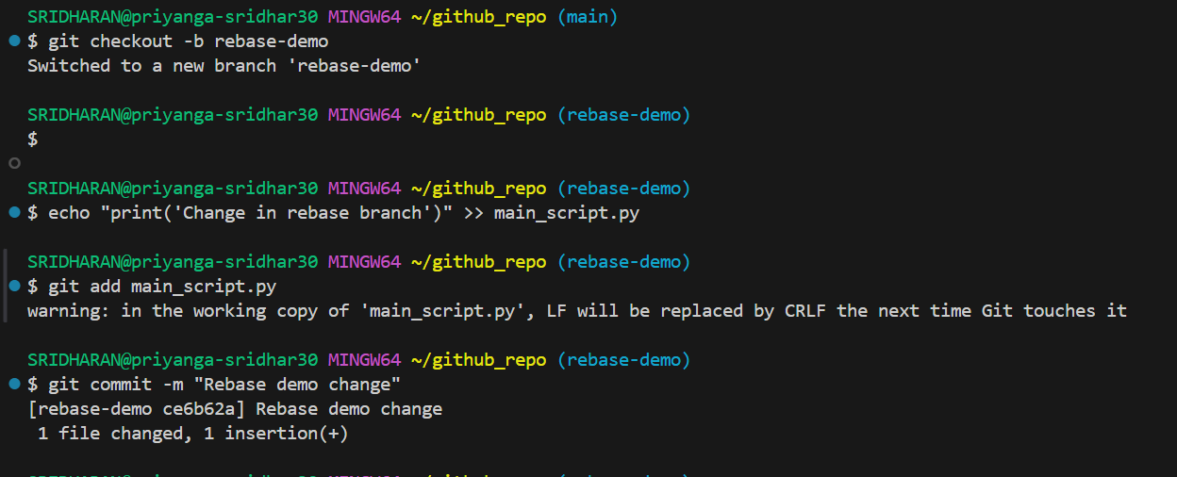

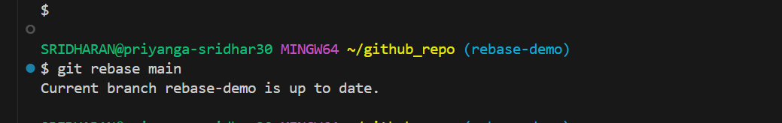

**Step 7: Stash Changes**

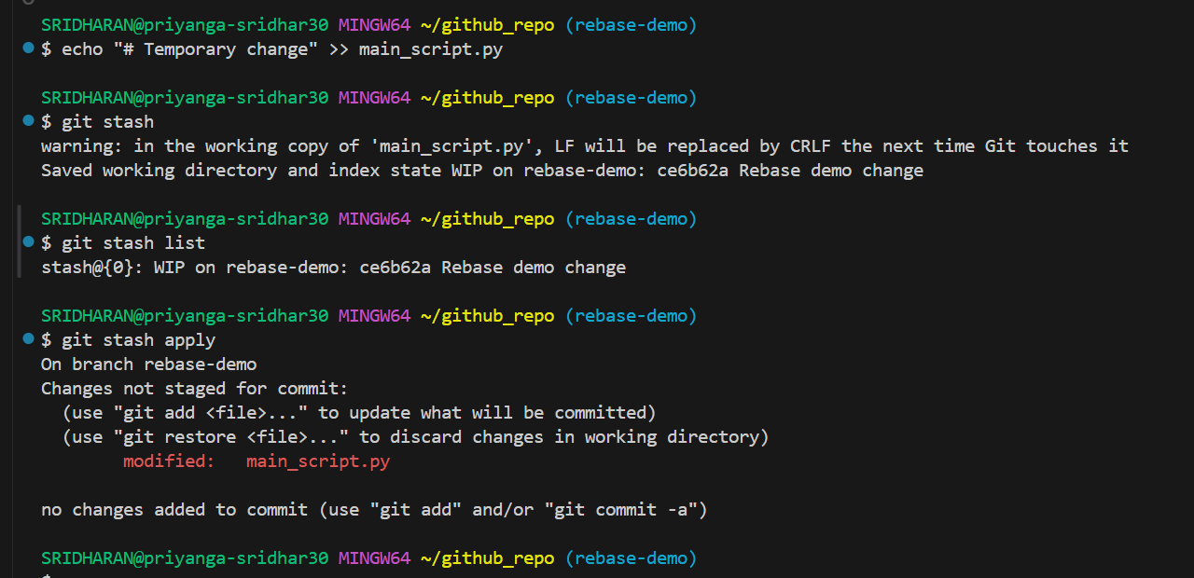

**Step8: Push All Commits to GitHub**

